This year’s survey was carried out over the course of one week in January. Both morning & afternoon sessions were included, & surveys for both GP and Nurse appointments were handed out. The survey was organsied by our PPG (Patient Participation Group) who were on hand during the day with pens, clipboards & to answer any questions patients had.
The survey was an duplicate of 2011/12, so we could get a comparison of feedback over a 2 year period on the same subjects. The only addition to the questions was to reflect that online appointments are now available as an option when patients are looking to book with a GP.
For each question that follows there is a breif summary comparing this year’s data to last.
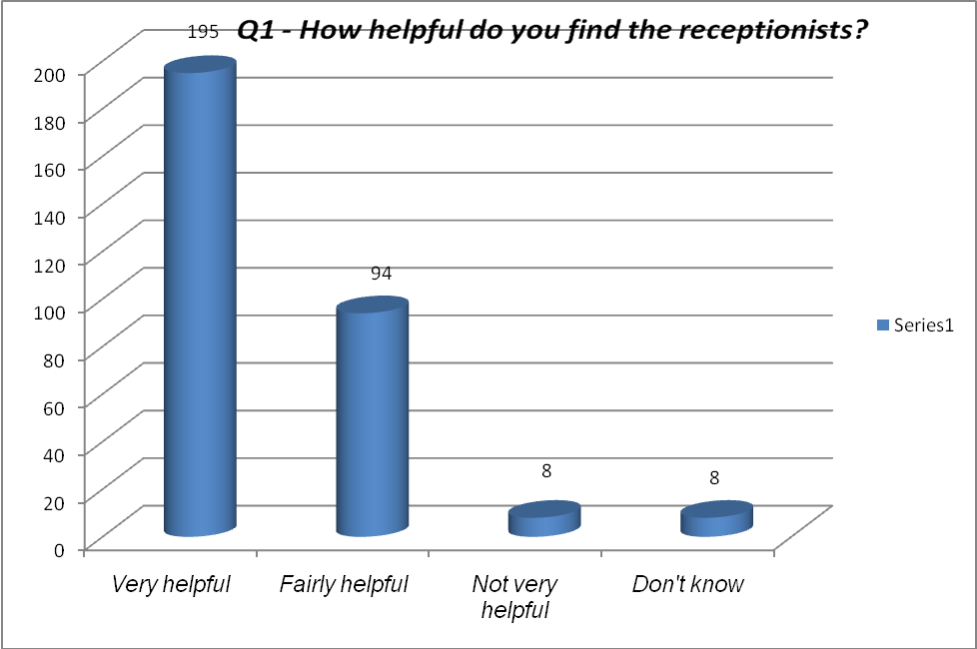
Very – increase of 2% from 62-64%
Fairly – reduction of 6% from 37-31%
Overall positive reduction from 98-95%
(added in a ‘don’t know’ option 2012/13)
(the ‘not helpful’ has increased marginally from 2-2.5%)

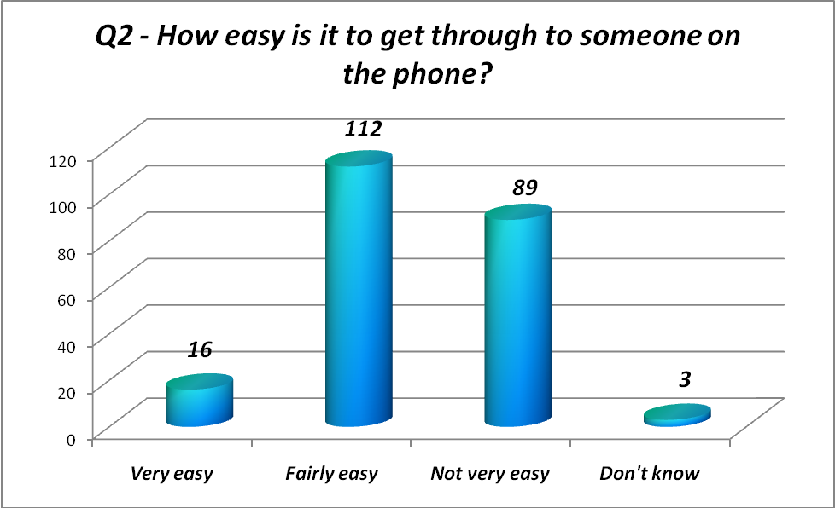

Very – reduction of 5% from 10-5%
Fairly – increase of 7% from 30-37%
Not Very – reduction of 2% from 57-55%
Don’t know – increase of 1% from 2-3%
(overall positive increase of 2% from 40-42%)

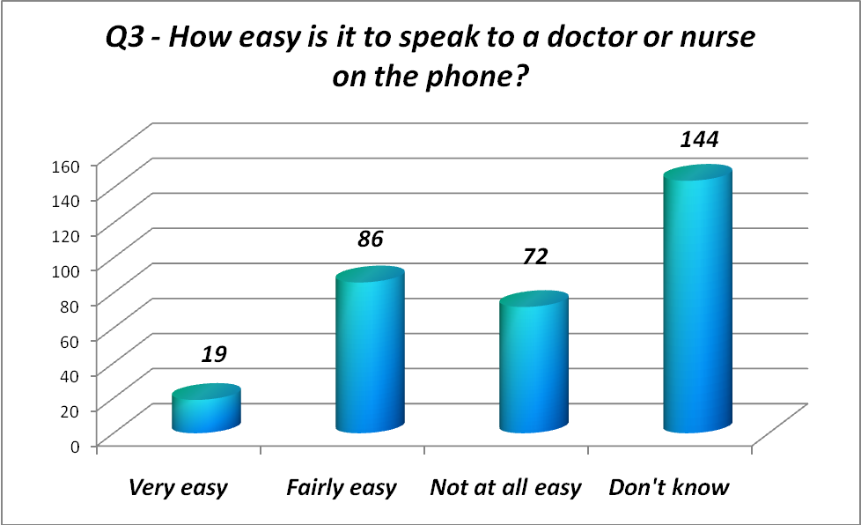
Very easy – reduction of 3% from 9-6%
Fairly easy – increase of 1% from 27-28%
Not at all easy – increase of 5% from 19-24%
Don’t know (increase of 3% from 44-47%)
(overall positive reduction of 2% from 36-34%)

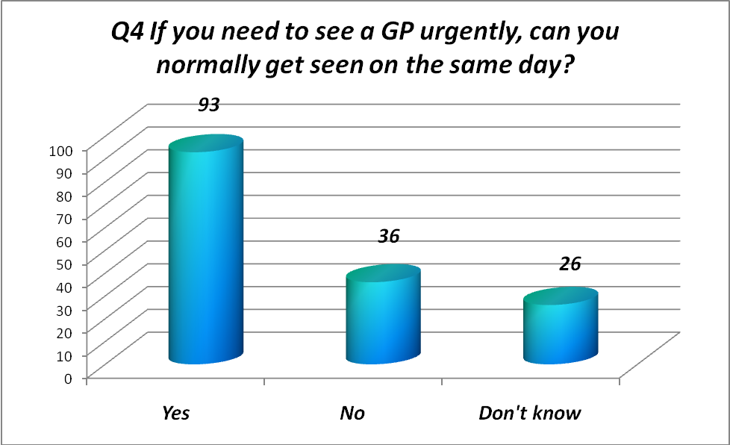
‘Yes’ – increase of 9% from 60-69%
‘No’ – reduction of 6% from 23-17%
‘Don’t know’ – 17% 2011/12 – 48% 2012/13

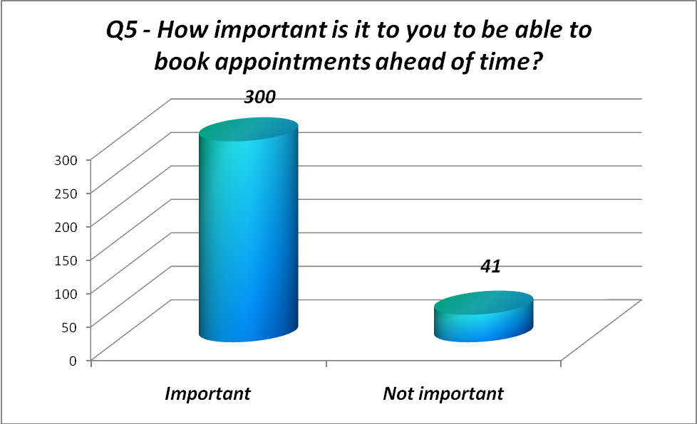
Important – increase from 77-98%
Not important (decrease from 23-2%)

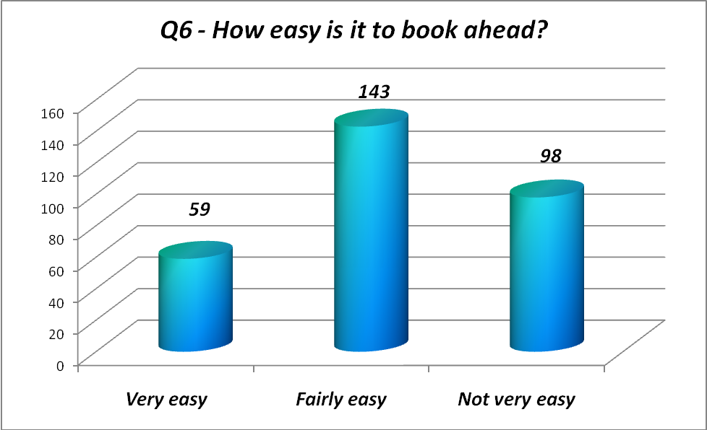
Very easy – reduction of 6% from 26-20%
Fairly easy – increase of 3% from 45-48%
Not very easy – increase of 3% from 29-32%

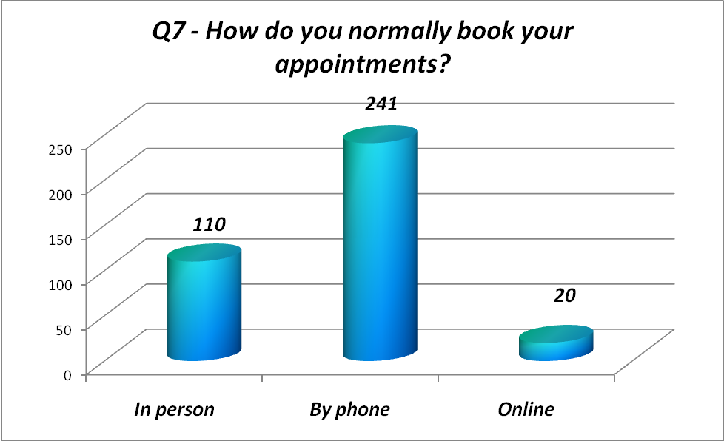
In person remains the same at 30%
65% book by phone compared to 68% last year
5% book online

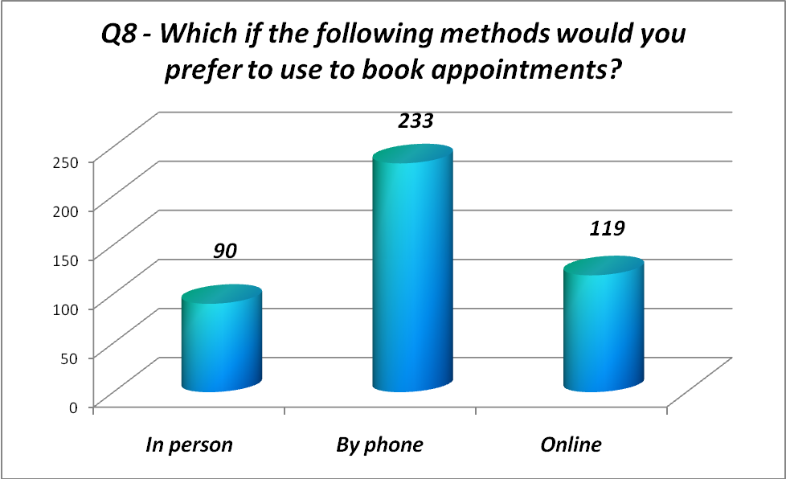
There is a shift from wanting to be able to book on the phone.
2011/12 had 84% wanting to book by phone
2012/13 has 53% wanting to book by phone
27% would like to book online (compared to 5% using this method now)

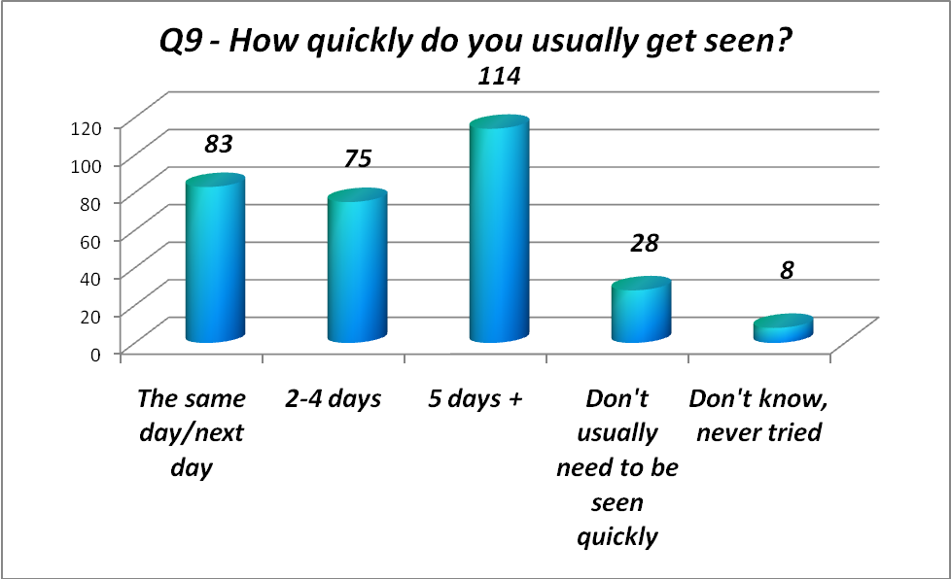

Same/next day – increase of 6% from 21-27%
2-4 days – reduction of 7% from 31-24%
5 days+ - increase of 2% from 35-37%
(don’t need to be seen quickly – increase of 2% from 7-9%
(don’t know, never tried – reduction of 3% from 6-3%)

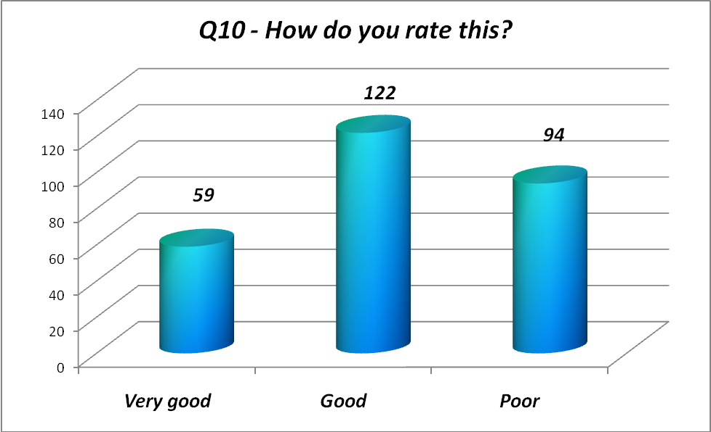
Very good – increase of 2% from 19-21%
Good – reduction of17% from 61-44%
Poor – increase of 14% from 20-34%

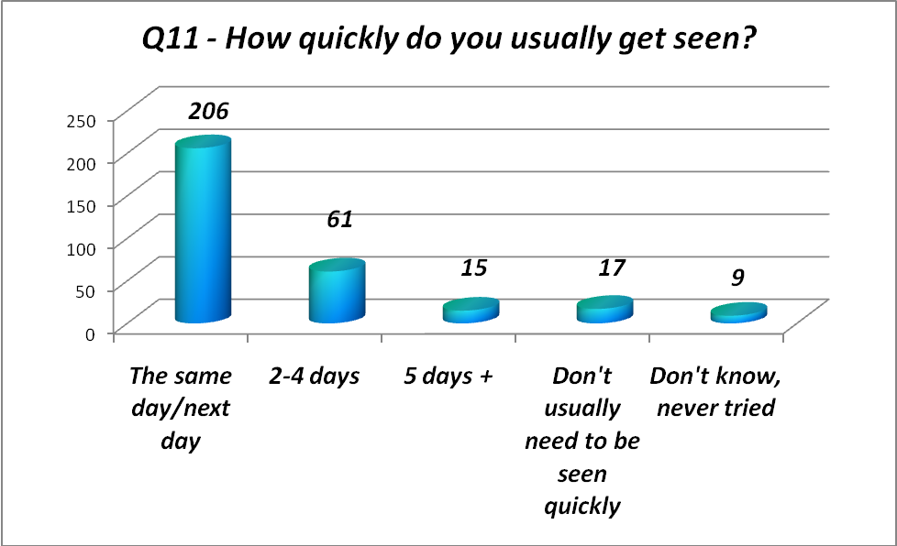
Same/next day – increase of 6% from 61-67%
2-4 days – reduction of 5% from 25-20%
5 days+ - reduction of 3% from 8-5%
(don’t need to be seen quickly – increase of 2% from 3-5%)
(don’t know, never tried – approx same)

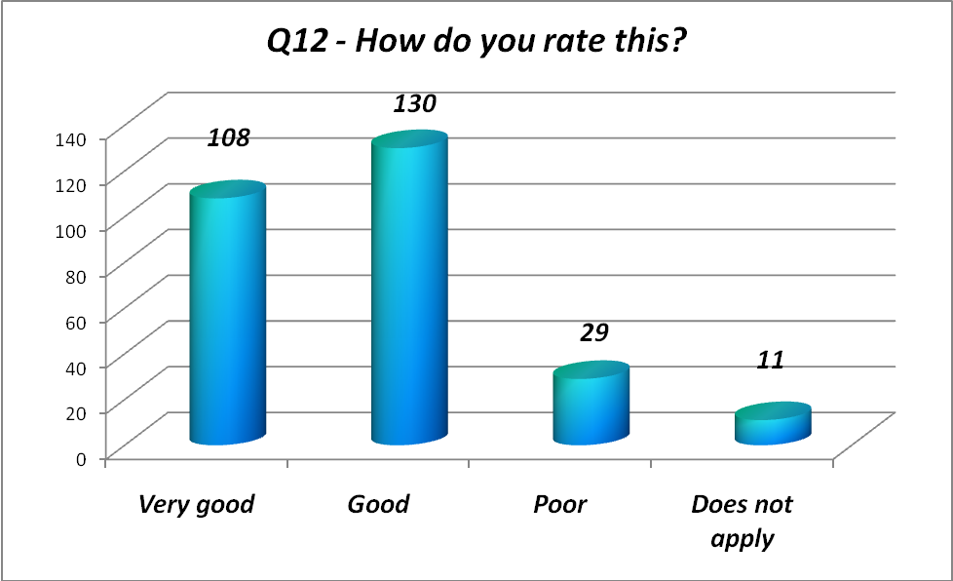
Very good – increase of 7% from 32-39%
Good – reduction of 4% from 51-47%
Overall positive increase of 3% from 83-86%
Poor – same 10%

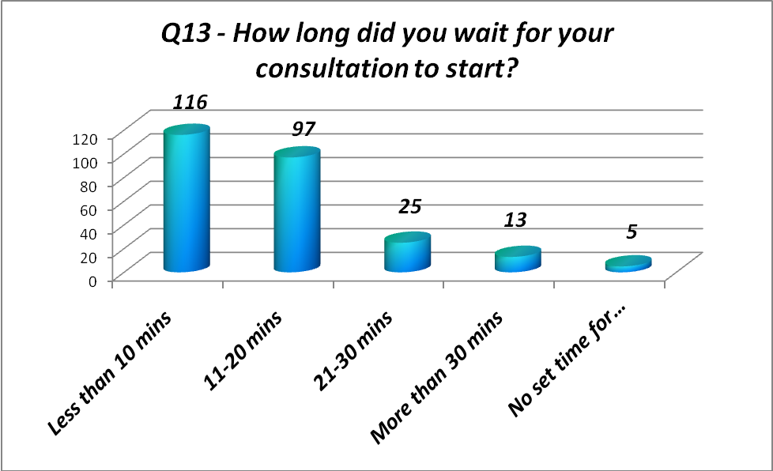
< 10 mins – increase of 10% from 35-45%
11-20 – reduction of 7% from 45-38%
21-30 – same (10%)
30+ - reduction of 2% from 7-5%
(No set time – reduction of 1% from 3-2%)
83% of patients surveyed waited less than 20 minutes to be seen (3% improvement on 2011/12)

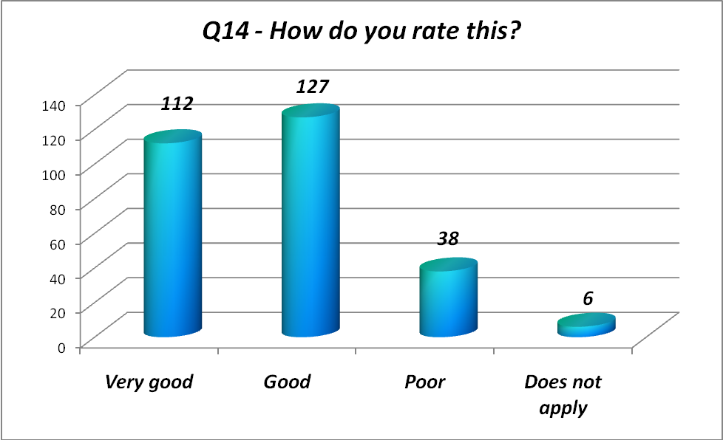
Very good – increase of 7% from 33-40%
Good – reduction of 5% from 50-45%
Overall positive increase from 83-85%
Poor – increase of 1% from 12-13%
Does not apply – 5-2%

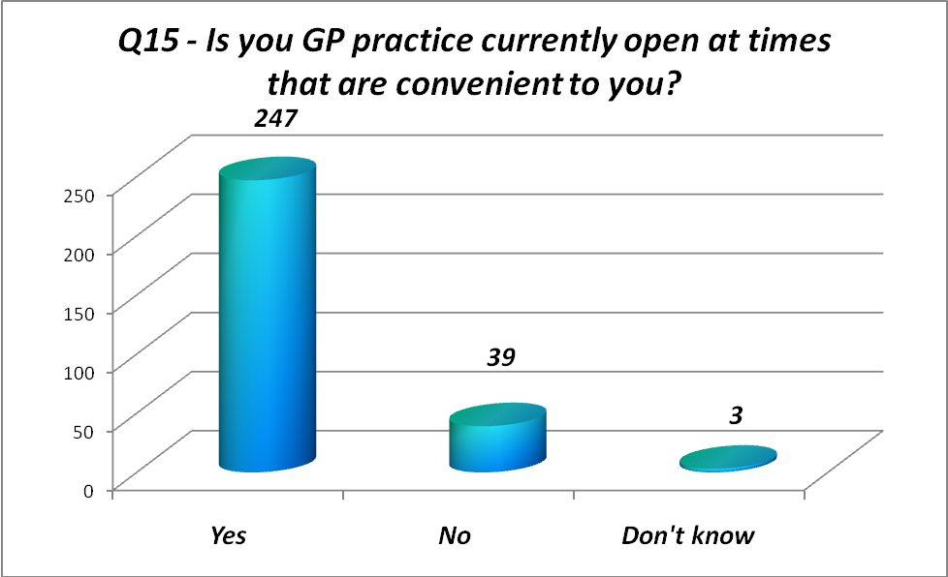
Yes – improvement of 6% from 79-85%
No – same (13%)
Don’t know – reduction of 6-2%

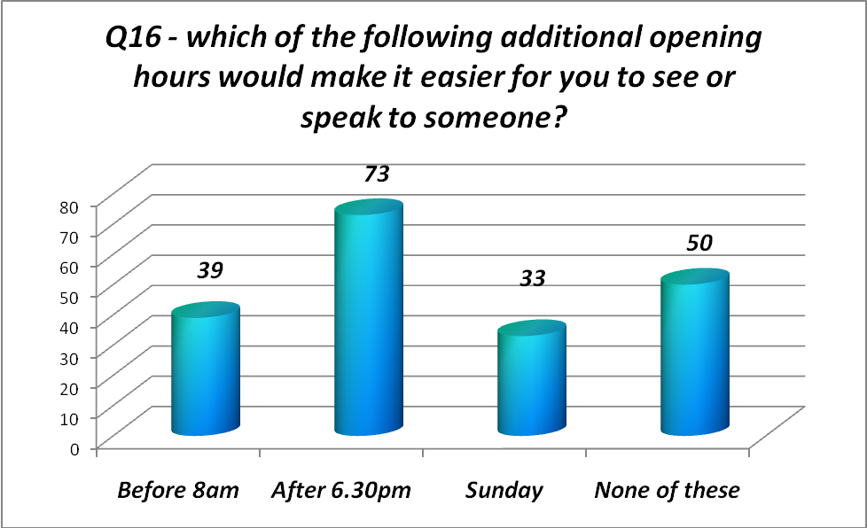
Before 8am – same 20%
After 6.30pm – increase of 16% from 21-37%
Sunday – increase of 11% from 6-17%
None of these – reduction from 54-26%

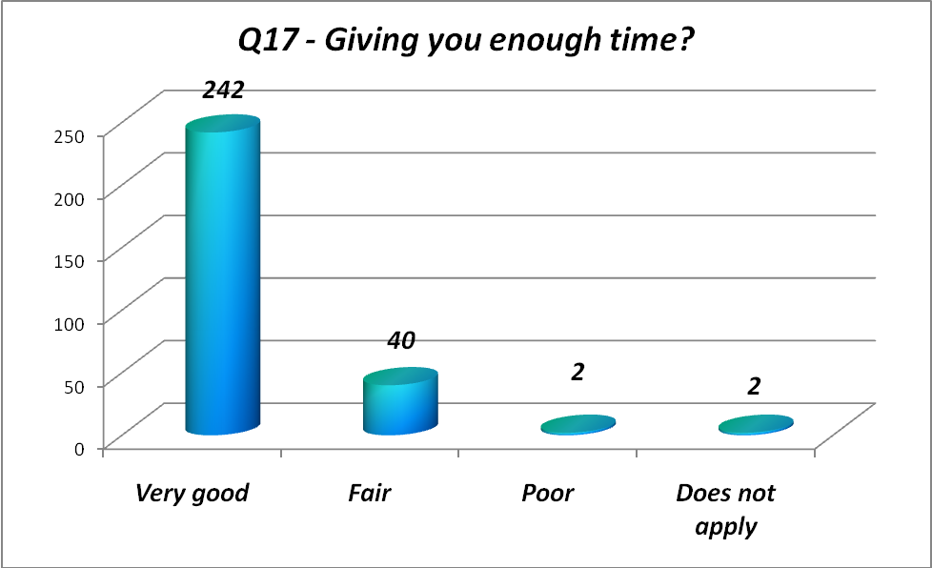
Very good – increase of 14% from 71-85%
Fair – reduction of 6% from 20-14%
Poor- 0-<1%
Does not apply
Overall increase of 5% from 94-99%

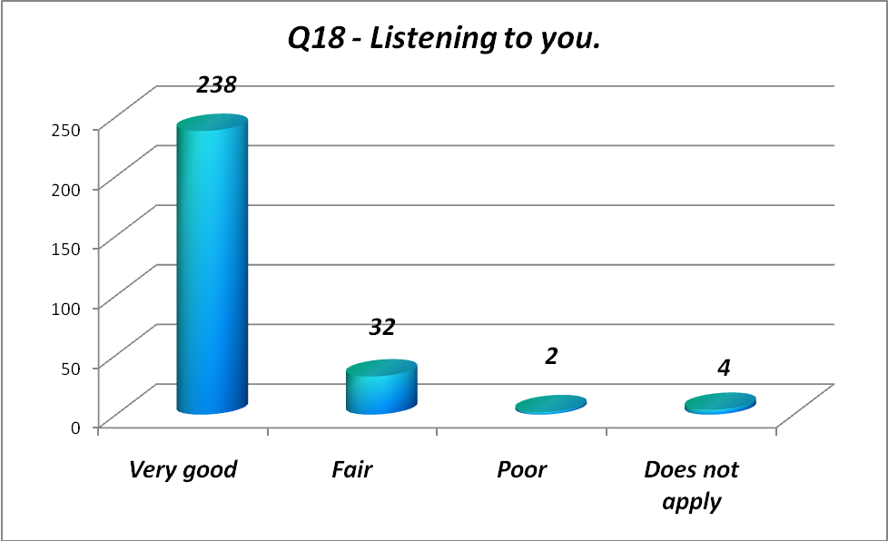
Very good – increase of 5% from 80-86%
Fair – reduction of 2% from 14-12%
Poor- 0-<1%
Does not apply
Overall increase of 4% from 94-98%

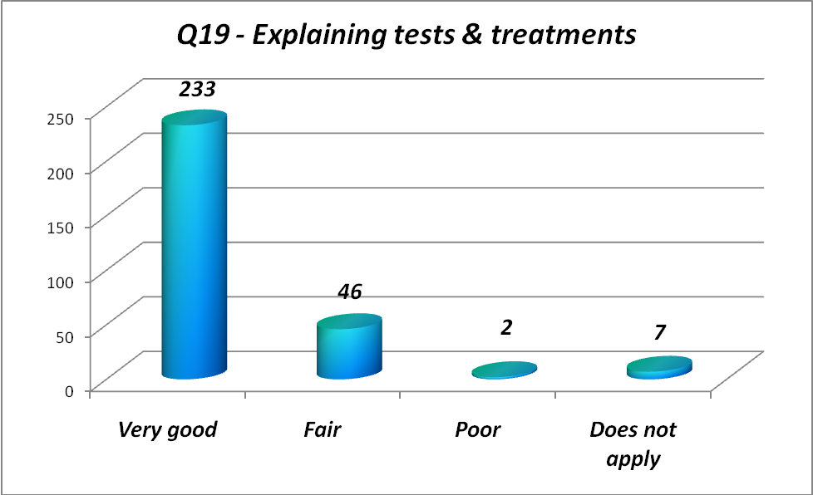
Very good – increase of 5% from 76-81%
Fair – same (16%)
Poor – 0-<1%
Does not apply
Overall increase of 5% from 92-97%

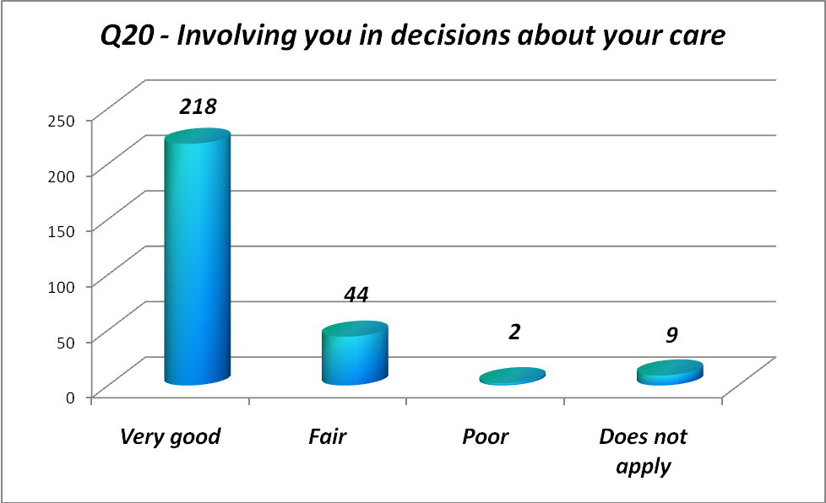
Very good – increase of 4% from 76-80%
Fair – increase of 1% from 15-16%
Poor – 0-<1%
Does not apply
Overall increase of 5% from 91-96%

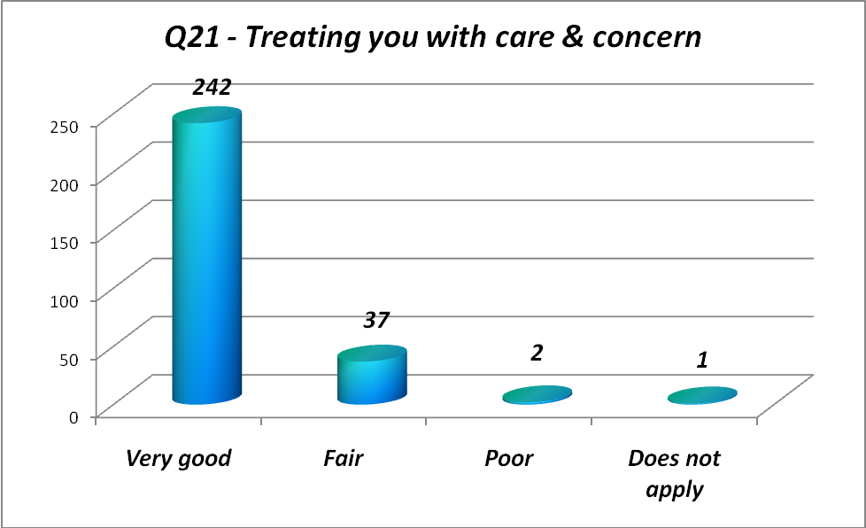
Very good – increase of 10% from 76-86%
Fair – reduction of 2% from 15-13%
Poor – 0-<1%
Does not apply -
Overall increase of 8% from 91-99%

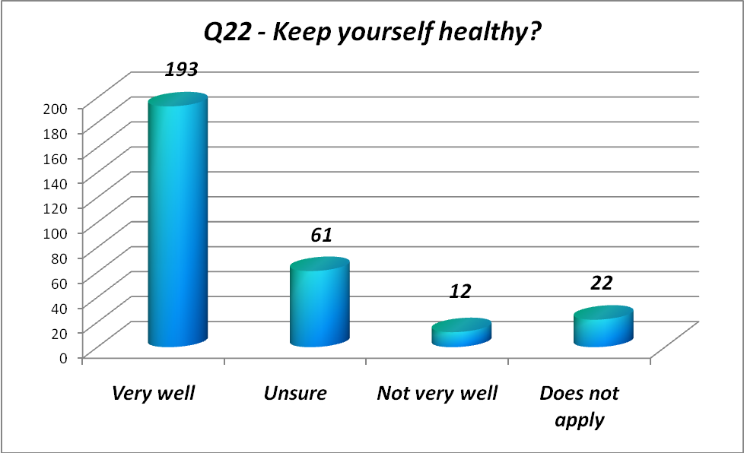

Very well – same (67%)
Unsure- reduction from 24-21%
Not very well – increase of 3% from 1-4%
Does not apply (increase of 5% from 71-76%)

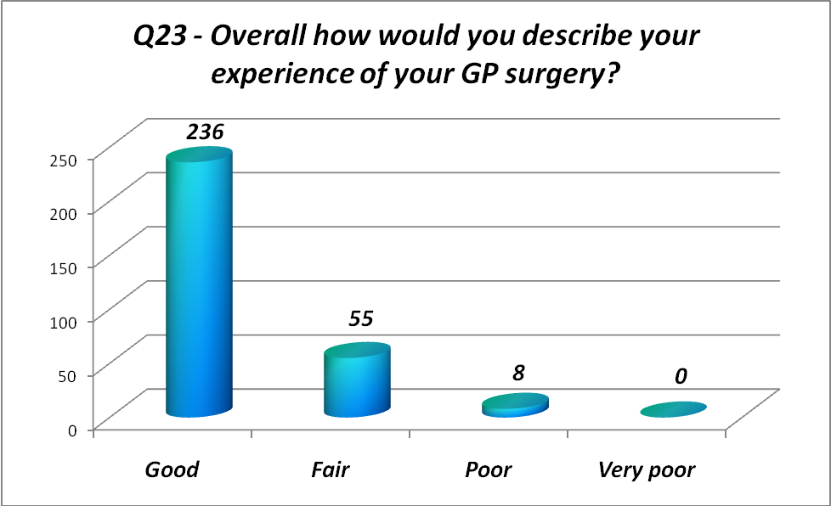
Good – Increase of 2% from 77-79%
Fair – reduction of 4% from 22-18%
Poor - increase <1%-3%
Very poor 0
Overall reduction from 99-97% in overall satisfaction

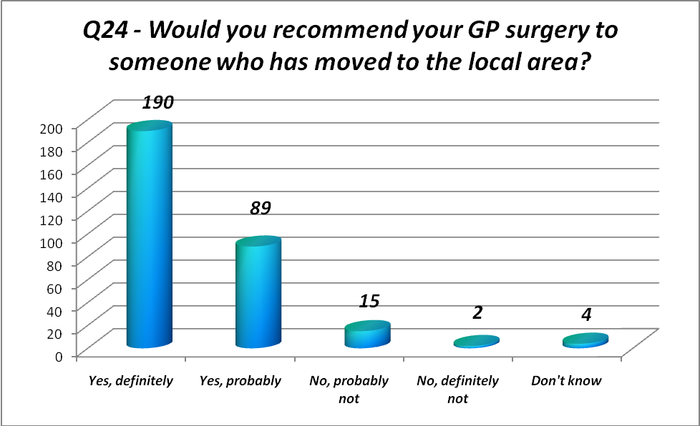
Yes, definitely – increase of 2% from 61-63%
Yes, probably - reduction of 2% from 32-30%
No, probably not – increase of 3% from 2-5%
No, definitely not- reduction from 1% to <1%
Don’t know - reduction 3-1%
Overall same positive 93%

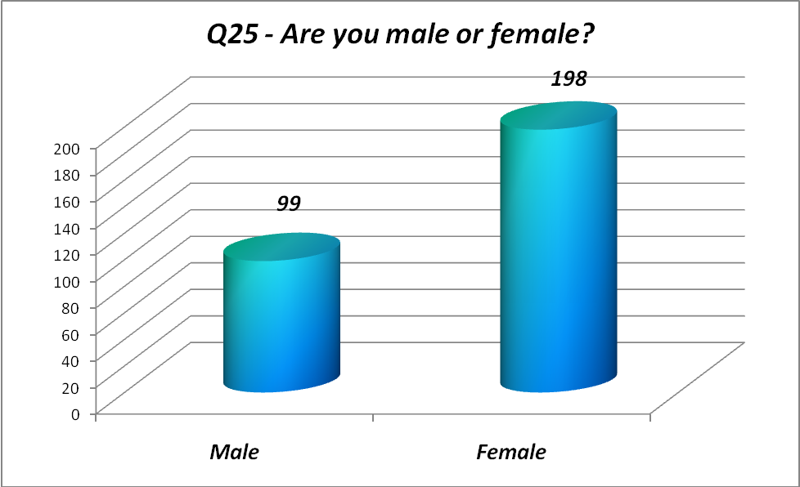
Male – reduction of 3% from 36-33%
Female – increase 3% from 64-67%

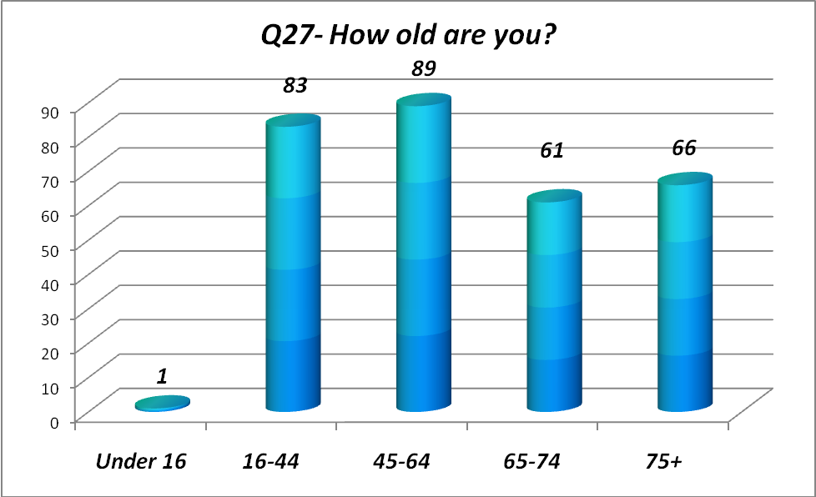
<16 – 3%-<1%
16-44 – reduction of 5% from 33-28%
45-64 – increase of 2% from 28-30%
65-74 – increase of 1% from 19-20%
75+ - increase of 4% from 18-22%

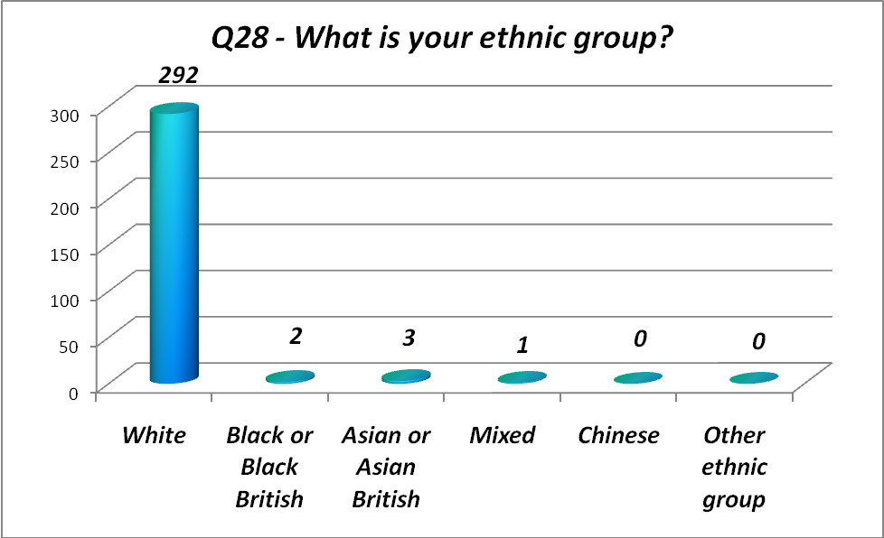
White – increase 95-98%
Black or Black British – increase <1% (0-2)
Asian or Asian British - <1%-1% increase (1-3)
Mixed – reduction 3-<1%
Chinese – reduction <1%-0
Other ethnic group – reduction <1%-0

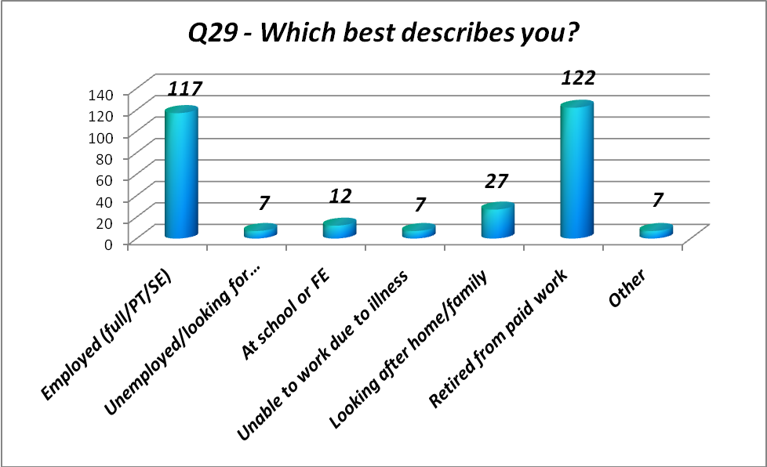
Employed – reduction of 5% from 44-39%
Unemployed/looking for work – increase from <1%-2%
At school or FE – reduction of 3% from 7-4%
Unable to work due to illness – increase 1% from 1-2%
Looking after home/family – increase 4% from 5-9%
Retired from paid work – same (41%)
Other – increase from <1% - 2%
As a result of this survey, the PPG, Practice Manager & Dr Julia Markham met at the beginning of March to discuss the findings & agree an action plan for the surgery to take forward into 2013/14. Please see separate action plan for details.

