Minutes of the AGM of Dorridge Surgery PPG held on
Monday 30th October 2017 at 7.00pm at the Surgery

1. Members Present.
Committee: Ian Black (Chair), Val Tabb (Secretary), Amanda Shakespeare (Practice Manager), Gerald Waight, Margaret Pers, Pauline Mathias
Patients: Annette Woodward, Judy McCarthy, David Wallis

2. Apologies
Yvonne Brodie

3. Minutes of last AGM
The minutes of the last AGM had been circulated to the members of the committee. Ian summarised the main points for the benefit of the non committee patients.
It was agreed by the committee that they were a true record.

4. Matters arising
There were no matters arising

5. Chairman's report
Ian circulated copies of his report to everyone present and a copy of this is attached as Appendix 1 at the end of the minutes.
He mentioned the PPG’s efforts to promote patient involvement with the setting up of the Patients’ reference group, major changes to the NHS locally with amalgamations within the Birmingham/Solihull area to commissioning bodies and hospital providers.
He provided figures for the use of both the PRG and the Surgery website for which he provides technical support
He also mentioned that we would all miss Don Eckley a long standing member of the PPG who sadly died recently

6. Report from the Surgery
Amanda gave her report in which she mentioned changes to the appointment system, the flu campaign, shortage of Pneumoccocal vaccine but return to supply of Hep A vaccine, access to online services, charges for NHS services, repeat prescribing and a lack of funding for a new glucose meter for diabetics.
Finally she mentioned that Dr Watts would be retiring on 31st December 2017and Dr Lim would become a partner on 1st Jan 2018.
A full copy of her report is attached as appendix 2
Judy mentioned how impressed she was by the efficiency of the flu campaign this year.

7. Election of Officers
Ian and Val said they were willing to stand for another year as Chairman and Secretary respectively and they were both re-elected.

8. A O B
Amanda reported that the Care Navigator service will have to end as no funding has been found for it to continue. There was general agreement that the service had been very valuable and great regret was expressed that it would no longer be available.
The practice managers of the Solihull GP alliance meet every week to work on unifying admin procedures but Amanda did not have anything to report as yet about joint clinical initiatives.

9. Date for next meeting - Tuesday 12th December
The 3 patients who attended all indicated that they might like to join the PPG and were invited to attend this meeting.

Appendix 1

Report from the chair 2017
Over the past 12 months the Group has continued to meet when required with the aim to develop the link between the Practice and the Patients.
The Patients Reference Group was implemented in November of last year with the first newsletter. Potential members were reached via SMS messaging, the Surgery Website and a message appearing on prescription slips. To date the membership is 181. When compared to other surgeries in the Borough this is quite good, however, a further drive will take place this next year to increase the numbers to be more representative of the patient base.
Some major changes are planned with the merger of Solihull, Birmingham Cross City and Birmingham South Central CCG’s this next year together with the Solihull GP Alliance, of which Dorridge Practice is a member.
Your Chair and your Secretary attend the Solihull PPG Network meetings (The secretary being on the Steering Committee) and the Solihull Patients Voice Panel with the CCG. We aim to maintain this during the coming year to include our voice in the future of the services within our area.
We welcomed three new committee members during the year, bringing medical knowledge and experience to the group. One of the younger members has moved on to Medical School at the University of Liverpool. We hope one day she will return as a qualified Doctor.
Sadly we recently lost a loyal and long standing member, who passed away in October. He was a retired Pharmacist and brought his knowledge to the table on many occasions. He will be sorely missed.

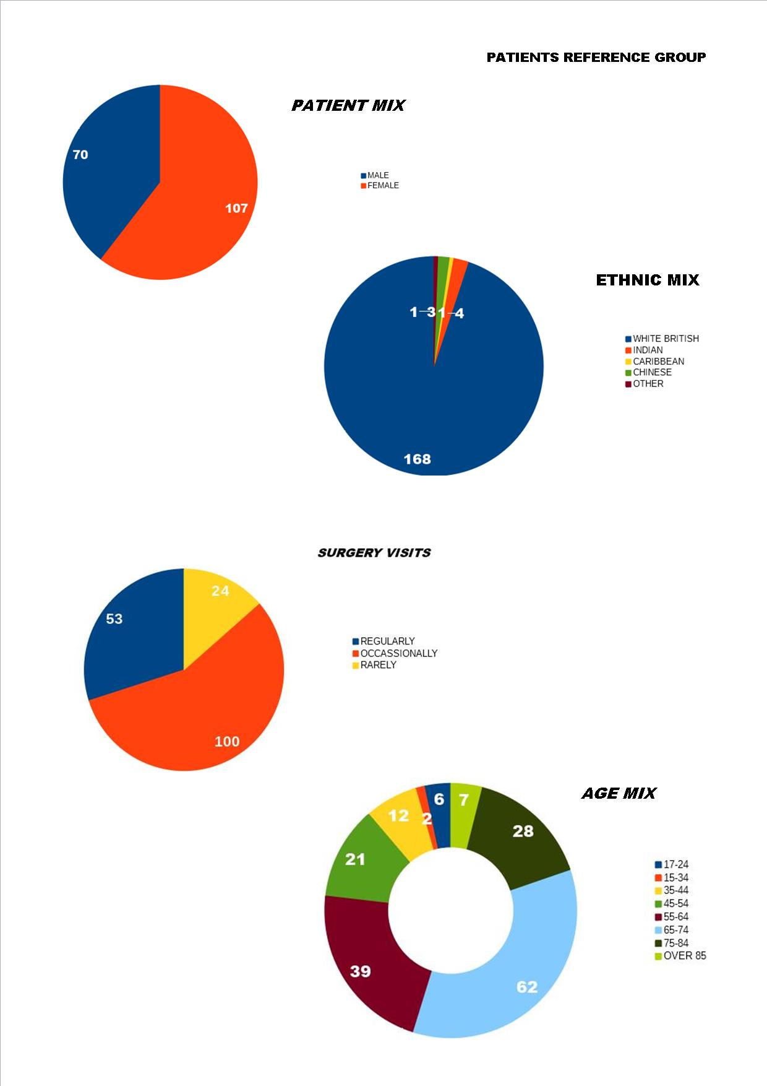

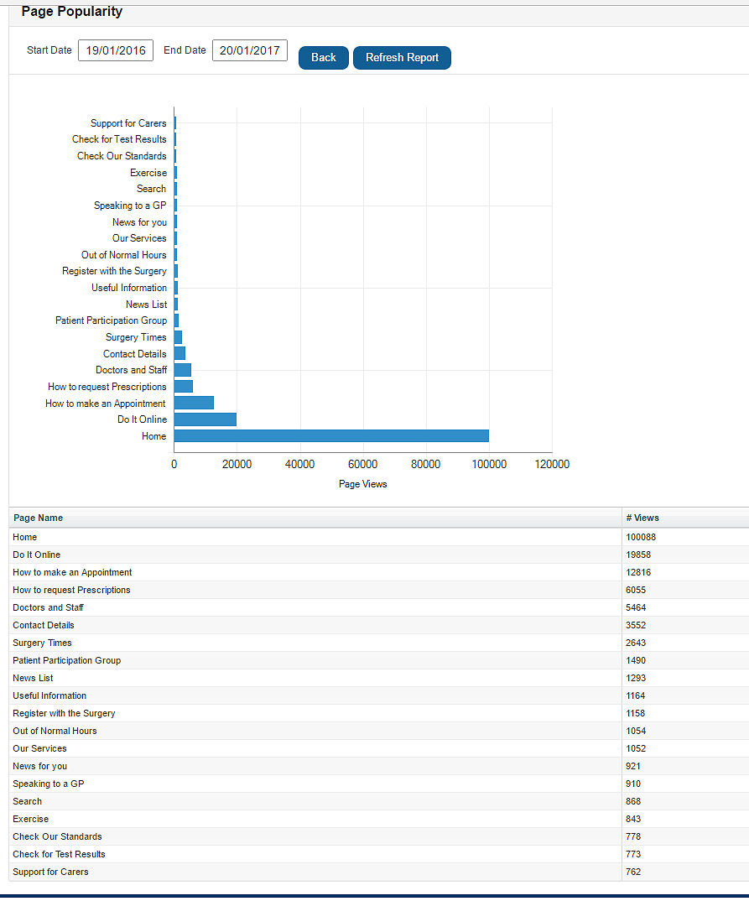

Appendix 2

Report from the surgery November 2017

Appointments

In April we introduced a new appointment system. We produced an appointment booking policy that was published on the website making the system transparent to all. We still see the same number of patients and have the same number of appointments, however we have been able to make more appointments available each day and have been able to secure appointments for patients where the GP’s require a review/follow up appointment. Part of the benefit of this is that we have less occasion to ask patients to ring back another day as much of the appointment booking is managed by the GP’s & receptionists and they contact the patient with times/dates etc.

In addition to this we have introduced our own internal waiting lists. These range from patients who need a 12 weekly B12 injection, to patients who need a follow up many weeks/months down the line. This means we are able to secure appointments in a timely fashion for patients, ensuring they don’t miss out on/forget to book their appointments. This is constantly being developed and recently we have added an ‘under 18’s flu’ waiting list which allows any of the staff to update the list on our computer system and for us to be able to judge the demand & therefore plan how to supply appointments.

Vaccines:

- Flu:

This year we have had our earliest ever delivery of flu vaccines, which meant we were able to do 2 x Saturday clinics and our follow up clinic much earlier and get more people vaccinated earlier – 2177 by 28th Oct, 97 u 18’s so far!

We have already secured a similar delivery time next year so plan to do another 2 clinics in Sept 2018.

- Pneumococcal & Hep A:

We had news at the end of last week that Hep A was back in stock, after national shortages due to an outbreak elsewhere in the world. We have therefore secured an order and will receive this week

There is however a national shortage of the pneumococcal vaccine. This vaccine is free on the NHS for anyone turning 65 (a once only vaccination), as well as certain high risk categories (some of which require a 5 yearly booster). National direction from Public Health England is that, until the vaccine shortage is over, we can only administer to newly diagnosed Hi Risk patients. This means the surgery cannot take bookings generated by patients, and can only invite in those that have been recently diagnosed with, or had

- spleen removed
- a long-term respiratory disease, such as chronic obstructive pulmonary disease (COPD)
- heart disease, such as congenital heart disease
- chronic kidney disease
- chronic liver disease, such as liver cirrhosis
- diabetes
- a suppressed immune system caused by a health condition such as HIV
- a suppressed immune system caused by medication such as chemotherapy or steroid tablets
- a cochlear implant (a small hearing device fitted inside your ear)
- had cerebrospinal fluid (the clear fluid that surrounds the brain and spine) leaking from its usual position – this could be due to an accident or surgery

As soon as this situation changes we will let patients know. For now we have opened up a waiting list so that when the time comes we can start actively booking patients in for their vaccination

Access to online services;

This is a reminder that patients wishing access to their medical records online can only make the request by a visit to the surgery. This is because we require photographic ID and a form completing. These measures are needed to ensure only the patient has access to their records. Patients wishing to have detailed coded records may have to wait at least 28 days before access is granted, as these requests have to be checked by a GP first. Unfortunately Systmonline is misleading & suggests you can request access via the online system, and it is out of our control to change this. What it does mean is that requests that are sent online for access are not actioned and patients will have to approach reception to get their access sorted.

Charges for NHS services:

There are many circumstances where patients require forms completing in full or part by a GP, or letters written to an official body, or medicals to declare fitness to a variety of activities. Whilst we provide clear information on our website and in the surgery about the costs associated with these services, and the length of time they can take, we still have people approaching GPs directly, or asking at very short notice for medicals and/or being unhappy about charges. We also have instances where patients expect that the GP should complete such forms quickly as they are ‘only ticking boxes’. GPs NEVER just tick boxes!! They have to examine a patient’s medical record before committing their signature/comments/medical details, & therefore this will never be a quick task to do. The charges applied are in line with BMA recommended fees, and we charge for all of these services because they are not part of the NHS core contract, and inevitably involve a GP taking time out of NHS time in order to complete forms/see patients for medicals.

Repeat prescribing:

The way repeat prescriptions are ordered changed from the 1st September 2017 and patients now have to order repeat prescriptions from the GP themselves. This only affected patients who previously had their medicines ordered by a local pharmacy. This measure was introduced to ensure that risks to patient safety, and any associated increase in waste medicines, are minimised, by asking patients to only order what they need when they need it. Vulnerable patients have not been affected by this change

Prescribing issue:

There is a new glucose monitoring product called the Freestyle Libre Glucose Meter. This is a new form of monitoring called flash glucose monitoring. The local Diabetes Medicines Management Network is currently considering flash glucose monitoring with a view to making a recommendation to the APC (Area Prescribing Committee) for formulary inclusion, however this & the funding required to make it available is not in place yet. We are therefore unable to prescribe this meter until further notice.

Out with the old….

Officially Dr Watts retires on the 31st December. He has had an awful lot of holiday to take though, which means his actual days left with us are only now 9 in number. He has been & will be for those 9 days, seeing patients, but only for book on the day.

His successor is our own Dr Lim, and she begins as partner on the 1st Jan 2018 (after the New Year bank holiday!)

