DORRIDGE SURGERY PATIENT PARTICIPATION GROUP

SURVEY & REPORT MARCH 2012

WHAT IS THE PATIENT PARTICIPATION GROUP (PPG)?
The Patient Participation Group has been established and active at Dorridge Surgery for over 12 years.
It is an open membership group that encourages involvement and attendance from all areas of the practice community.
The group has been instrumental in acting as a critical friend advising the practice of the good, and where improvement is required.
The group promotes good health and a higher level of health literacy by encouraging and supporting activities both inside and out of the practice, and promoting preventative medicine.
Our PPG successfully runs an exercise group called ‘Extend’ & a ‘Striders and Strollers’ group – information on both is available in the surgery.

PPG AND PRACTICE PROFILE
Over the last 12 years the group has had between 6-7 members. Some members joined the group at the beginning; some have joined along the way and others more recently. Other members have also left the group due to other commitments or circumstances.
Demonstrating how a Patient Participation Group is Representative
Practice Population Profile | Population Surveyed | PPG Group
Age
19% Under 16 | 0% Under 16 | 0% Under 16
27% 16-44 | 16-44 | 16% 16-44
30% 45-64 | 45-64 | 28% 45-64
11% 65-74 | 65-74 | 28% 65-74
12% Over 75 | Over 75 | 28% Over 75
Ethnicity
93% White | 99.7% White | 100% White
1% Mixed | 0.3% Mixed | Mixed
2% Asian | 0.1% Asian | 0% Asian
2% Black | 0% Black | 0% Black
1% Chinese | 0.1% Chinese | 0% Chinese
1% ‘Other’
Gender
49% Male | 36% Male | 30% Male
51% Female | 64% Female | 70% Female

STEPS TO ENSURE GROUP WAS REPRESENTATIVE/REASONS FOR DIFFERENCE IN GROUP AND PRACTICE PROFILE
We encourage participation and a representative make up of the PPG in many ways. The group discusses and debates recruitment and representation on a regular basis.
The PPG quarterly newsletter is used to raise awareness and appeal for membership. We use a specific PPG notice board in the surgery to invite interested patients to contact the practice manager. There will be a “join the group” feature on our practice website and a silent television screen soon to be installed will also promote the PPG/membership. What has been most successful in gaining new members has been word of mouth.
The group only represents patients of a white ethnic group. Our practice population is 93% white and the makeup of the PPG reflects this.
For the age range the GP’s actively approached patients from the age groups 16-44 & 45-64 as in 2011 there was no representation from this group. Through approaching patients opportunistically, in addition to advertising in the quarterly newsletter & on the notice board, a patient studying her A levels joined the group, along with a patient who has links with a local pharmacy.
As a result the balance of representation in age terms has improved dramatically.

PPG FREQUENCY
Our PPG meets face to face within the practice or at a local member’s house a maximum of every eight weeks.
The meeting is usually held on a Tuesday at 7pm, as the PPG members include patients who work full time or are at school. It has recently been agreed to alternate the days between a Monday and Tuesday, and for them to be a little earlier so it suits all members & representatives from the surgery.
The PPG has discussed the survey since July 2011, at 3 separate meetings. This included agreeing the content and questions within the survey and how it was to be distributed.

Recent meetings have been held on 1/11/11; 6/12/11; 31/1/12 & 6/3/12 with all meetings minuted by the group secretary.
The practice team discussed the survey results prior to the PPG meeting on the 6th March 2012 and in particular how we could address areas that needed improvement. The team contributed ideas and helped develop the action plan.

PATIENT SURVEY

AREAS OF PRIORITY & HOW THEY WERE DECIDED
The survey was first discussed at a meeting 19/7/11 to agree a new surgery questionnaire. A further meeting was held on the 28/7/11 to discuss making changes to the previous year’s survey – by choosing questions that reflected what patients have asked about or queried about the surgery. Each member of the PPG was asked to consider questions they thought relevant in this context. The group chose to focus on key patient priorities, issues and themes. These include access (opening times, ability to book appointments quickly and in advance, telephones) and patient’s experience of the treatment they receive.

SURVEY PROCESS
The PPG agreed to host the survey in the practice for 1 week commencing 16th January. Different members of the PPG came in on different days & at different times in order to obtain a range of feedback from the surgery’s demographic of patients.
It was agreed to aim for 25 surveys per GP, and pre printed surveys were organised so the PPG members could identify which GP was being seen & give out the appropriate survey.
The team encouraged patients to complete the surveys and return them into a sealed box at reception.
After the surveys were taken the final results were analysed in house, with the Practice Manager taking the time to review each individual survey, record the result and the comments.
The results were e-mailed to all of the PPG members, & the individual GP’s, and discussed at a meeting held on the 6th March 2012.

RESULTS

155 surveys were collected over 4 days in the surgery.
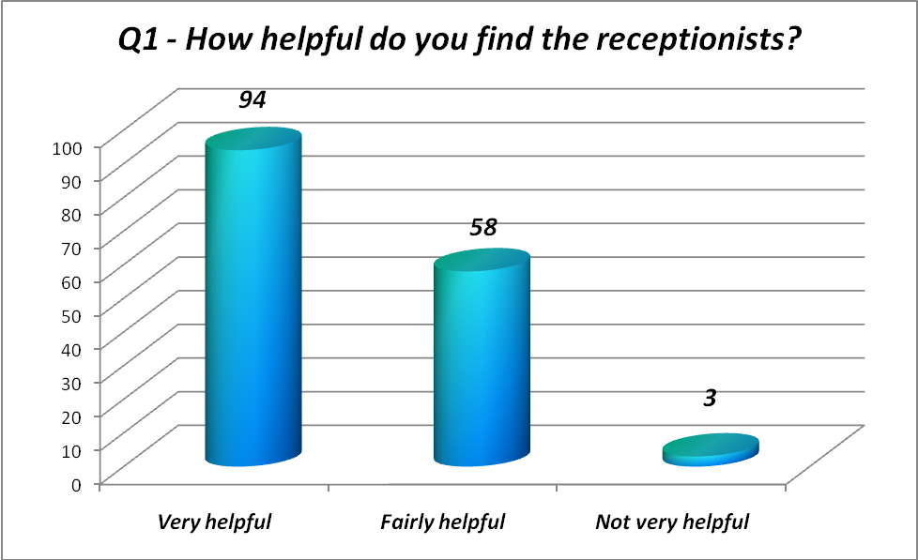
62% of patients found our receptionists to be very helpful
37% said they are fairly helpful – this result could be improved.
Less than 1% said the receptionists are not very helpful.
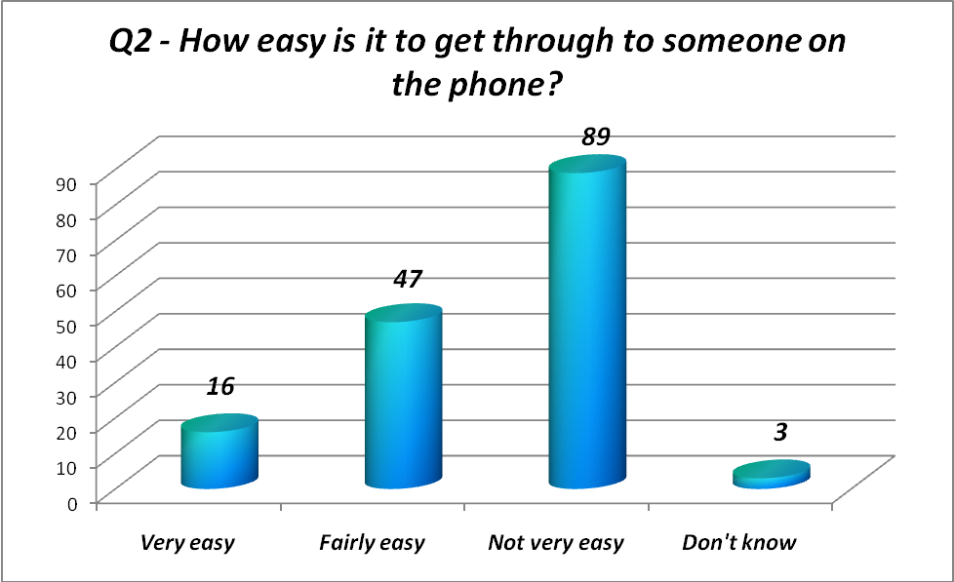
Only 10% of our respondents felt it was very easy to get through to someone on the phone. This is being taken forward in our action plan as we would like to dramatically improve these results.
30% found it fairly easy, & 57% thought it was not very easy to get through to someone on the phone.

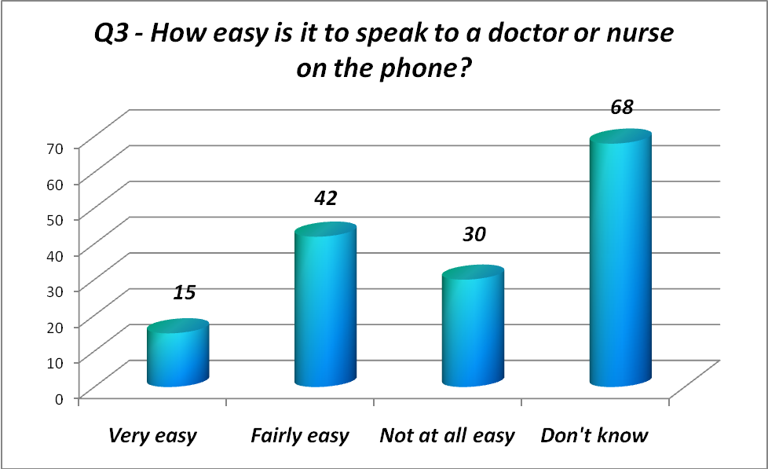
10% of respondents felt it was very easy to speak to a nurse or doctor on the phone.
20% felt it was not easy at all. Since the survey has been carried out there has been a new messaging system introduced, & patients that call to speak to a nurse or a doctor are given a timescale for a return call & currently this commitment is being met. Once this system has had time to take effect we will be able to measure results again in a future survey to test whether the system has improved our patients view on being able to speak to a nurse or doctor on the phone.
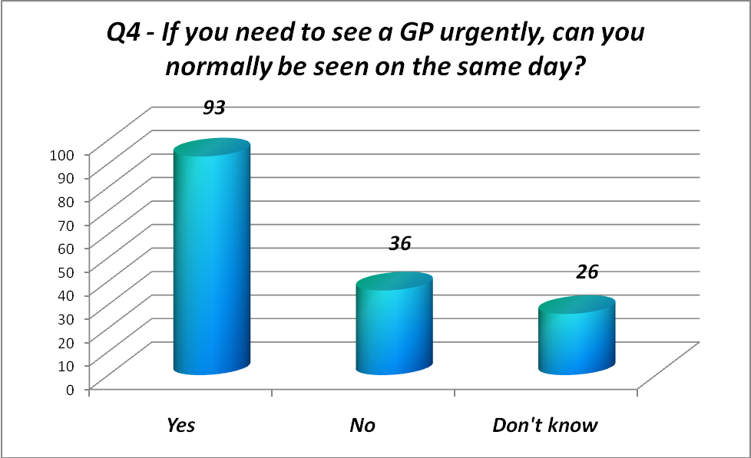
60% of those completing the survey felt that they can normally be seen on the day.
Out of those asked 17% didn’t know, & 23% disagreed with being able to be seen on the day for an urgent matter.
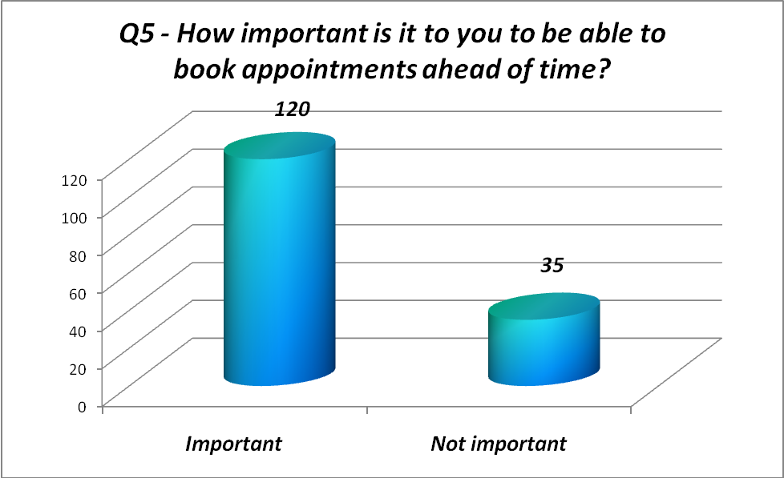
77% of our patients believe it is important to book appointments ahead of time.
The following question reflects how well the respondents feel the surgery performs on this area:
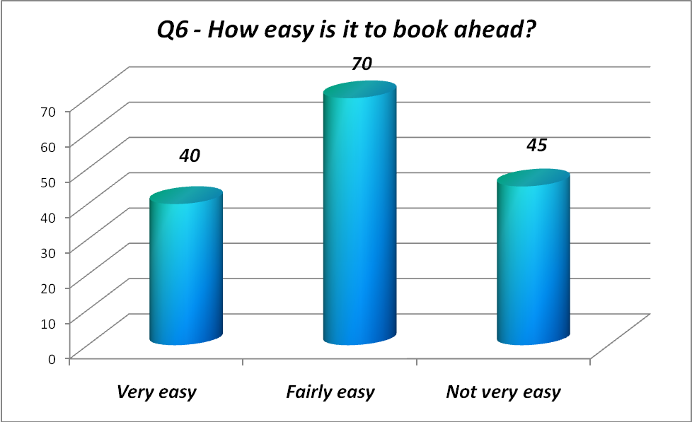
Over 70% of the respondents felt it was either very or fairly easy to book ahead. To address some of the possible concerns over appointment booking steps are being taken to improve the process. Please see the action plan.
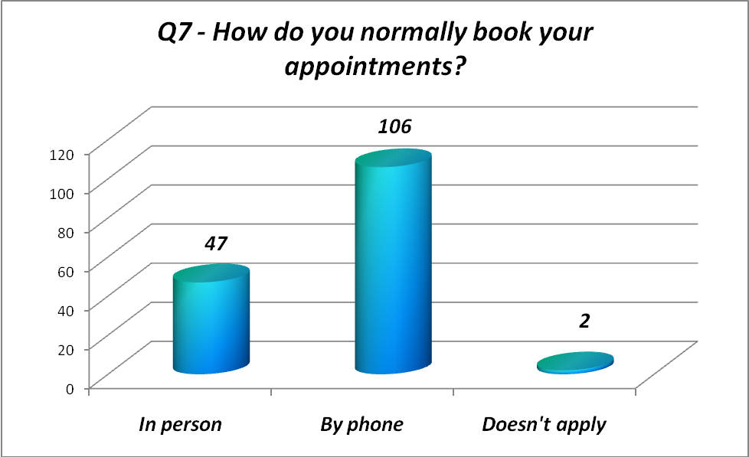
68% of the respondents book their appointments over the phone. In addition to this question there were a number of comments raised on the survey regarding the availability of appointment booking online. This is an area that is being addressed and is reflected in the action plan.
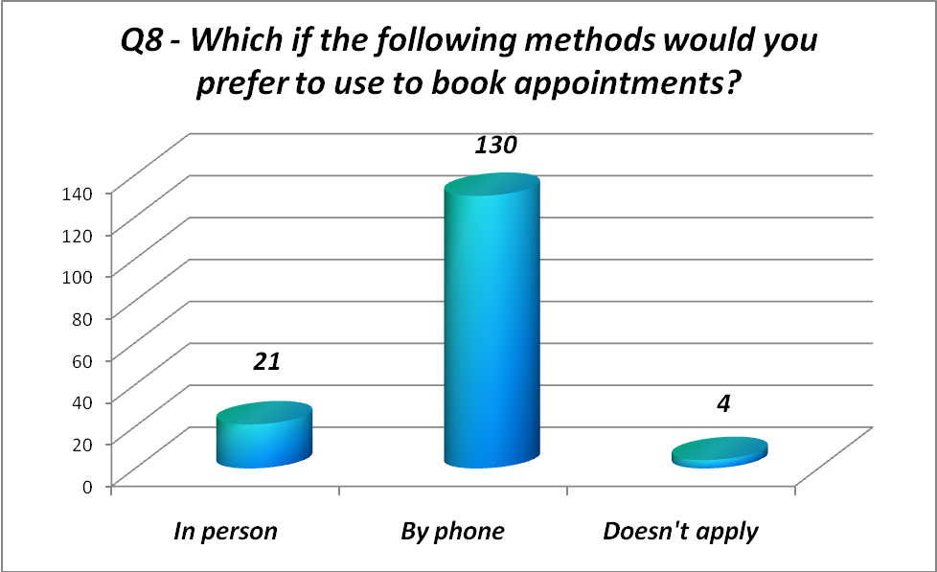
Given the choice of ‘in person’ or ‘by phone’ 84% of patients surveyed would prefer the phone option. In order to deliver a good service over the telephone the process is also being reviewed (in addition to the introduction of internet booking).
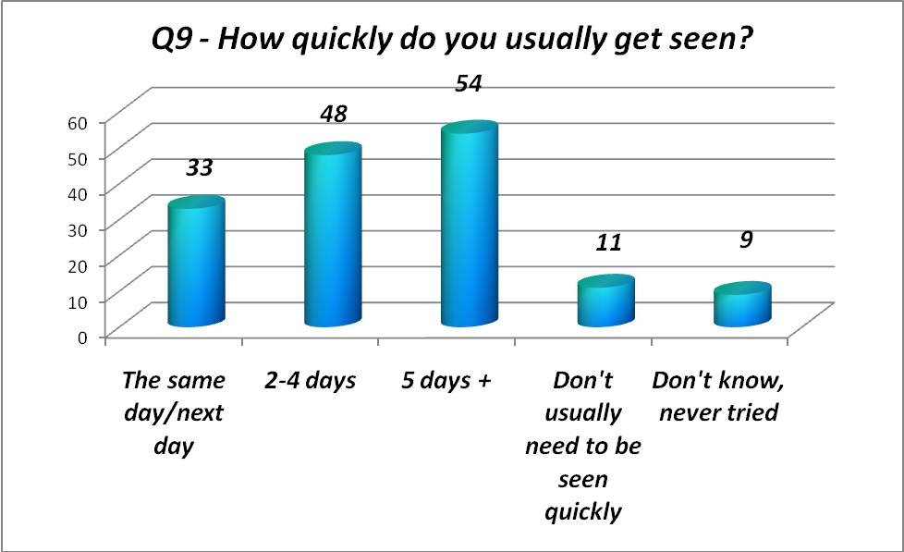
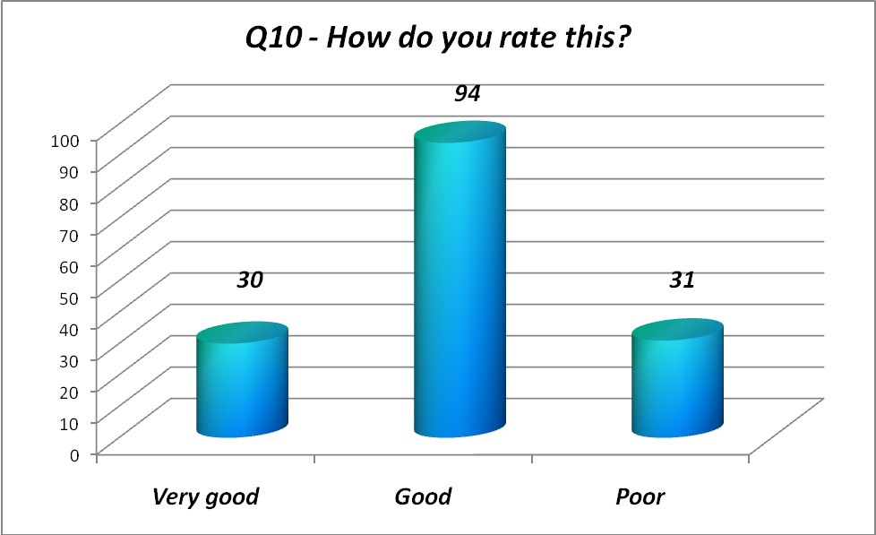

Whilst there were a variety of responses for how soon a patient can get to see a particular doctor, 80% of respondents felt this was either ‘very good’ or ‘good’.
The results change quite significantly for those who are willing to see any doctor:
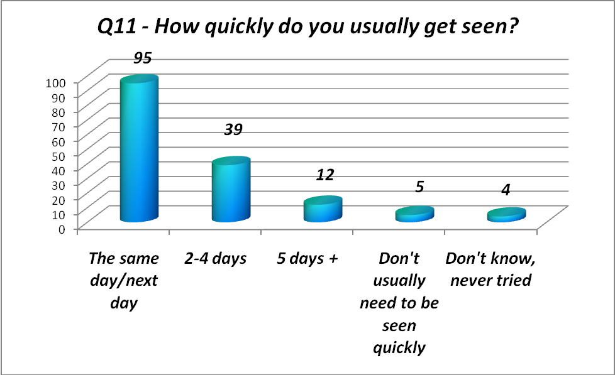
The rating of ‘very good’ & ‘good’ increase to 83%.
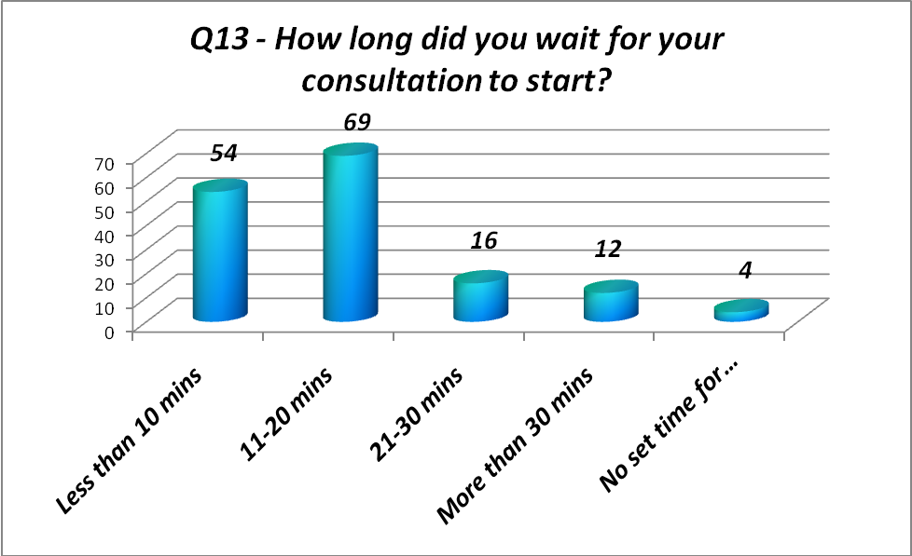
79% of respondents waited up to 20 minutes for their consultation to start.
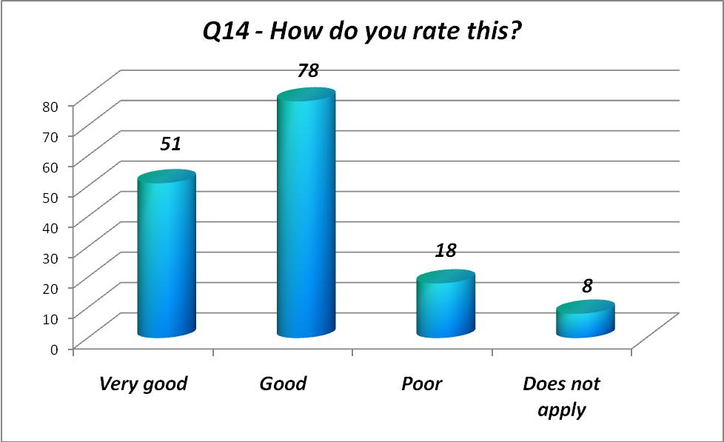
With 83% of patients reporting this to be ‘very good’ or ‘good’.
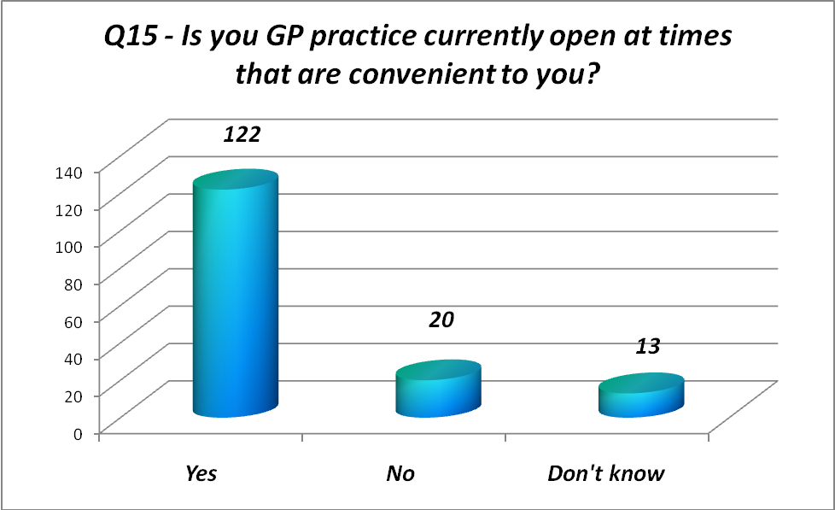
79% of patients feel the surgery opening times are convenient.
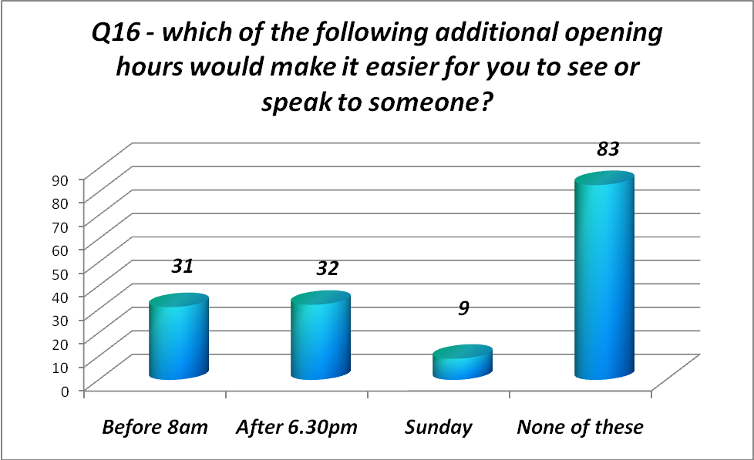
40% of respondents would prefer to be able to speak to or see someone outside of current opening hours. Our website will be improved to give up to date information on how to access medical advice out ot hours, & will also be advertised on the television screens soon to be installed in the surgery (see action plan)
The next few questions relate to the performance of the doctor themselves:
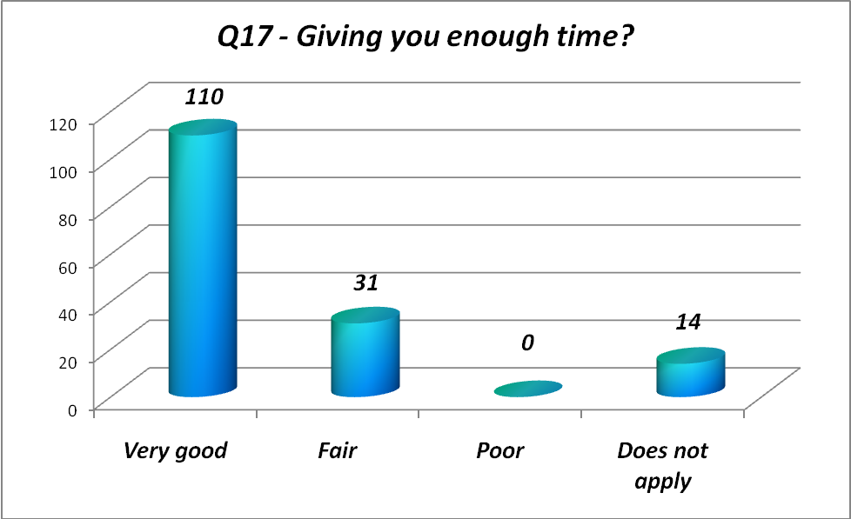
71% of respondents felt the time given by the doctor was very good, with not one patient recording a ‘poor’ result.
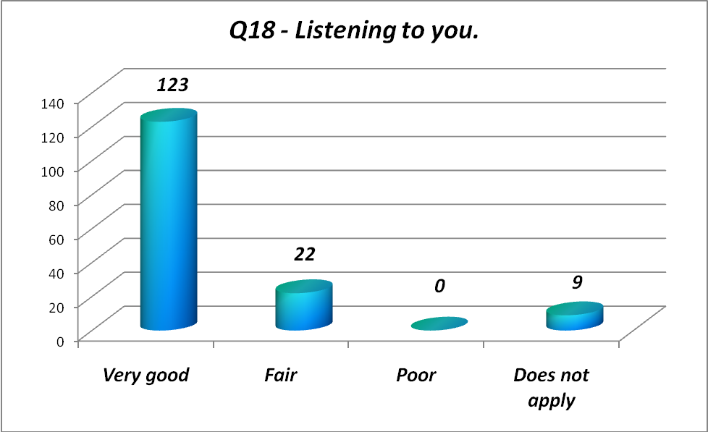
79% felt the doctors a very good at listening to them.
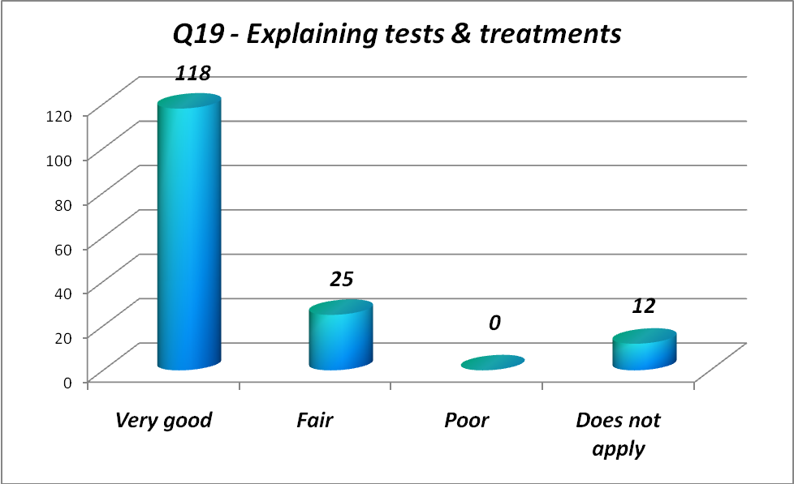
76% feeling that the doctors are very good at explaining tests & treatments.
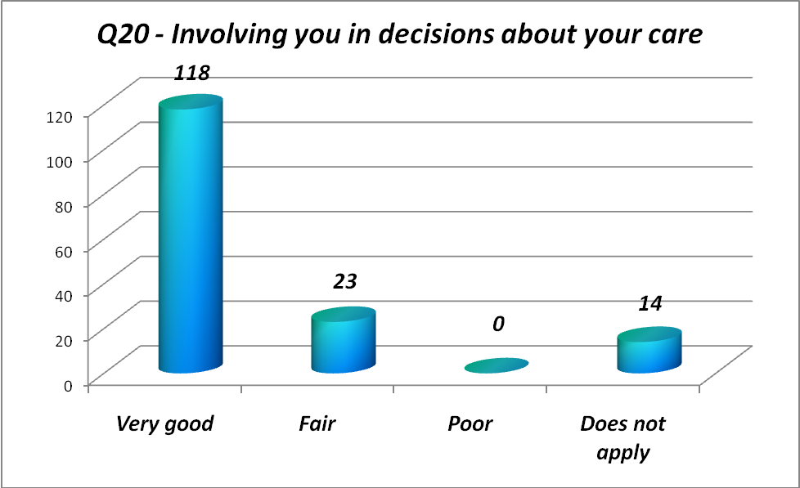
76% of respondents fell that the doctors are very good at involving them in decisions about their care, & the same number think that treatment with care & concern is very good.
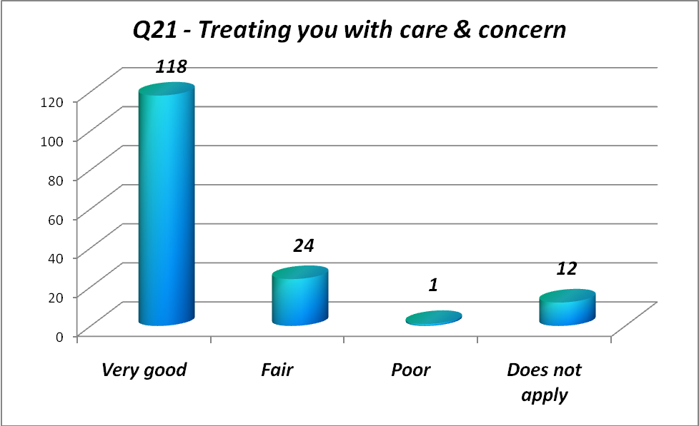
Thinking about the care you get from your Dr’s & nurses overall, how well does the practice help you to:
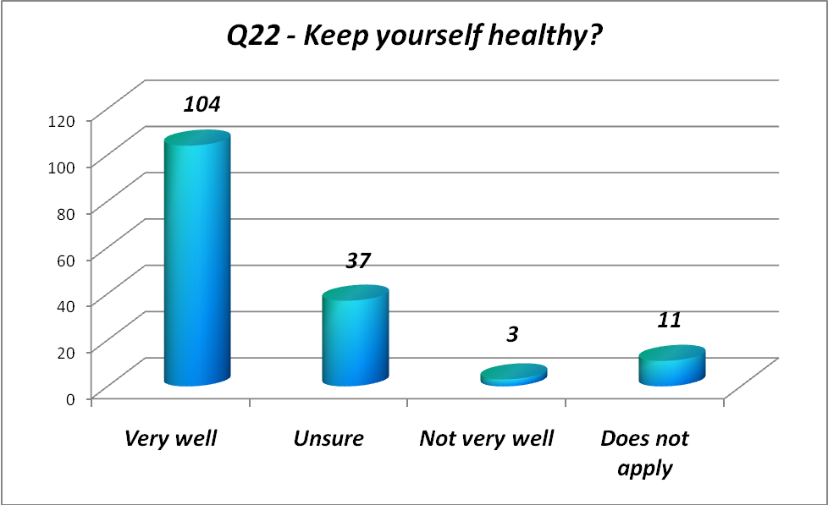
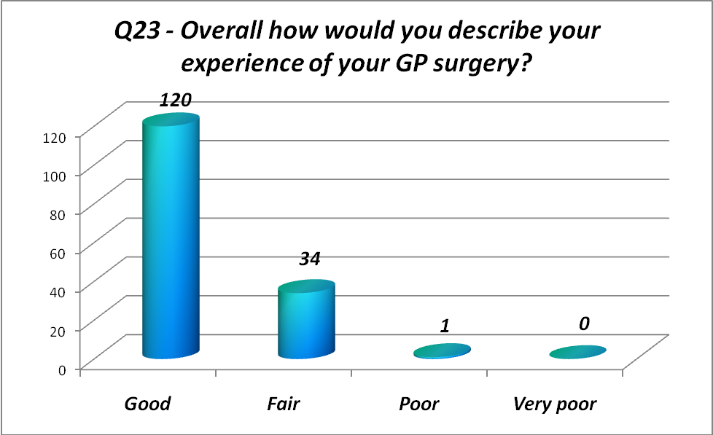
77% of respondents felt the overall experience of the surgery was good.
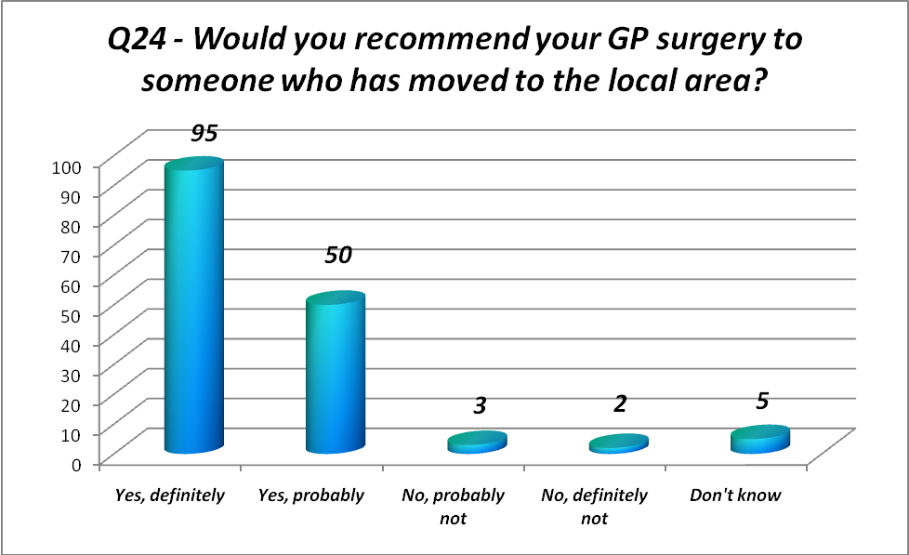
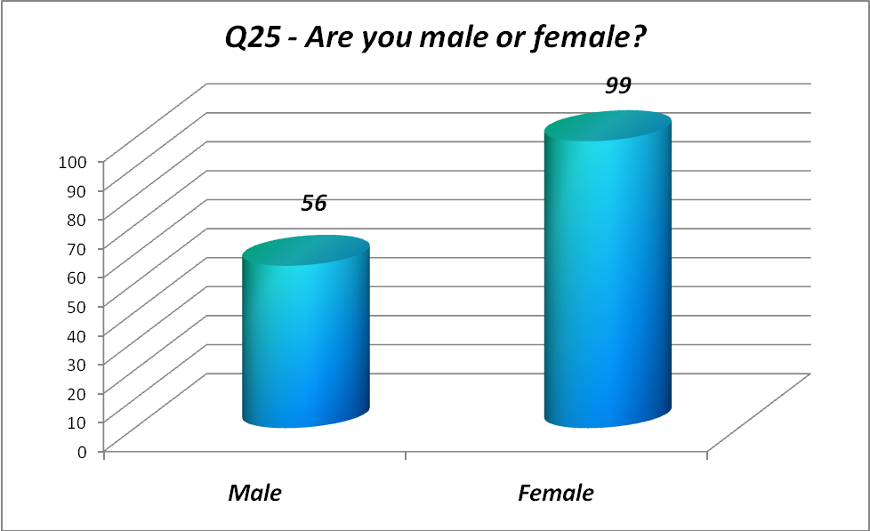
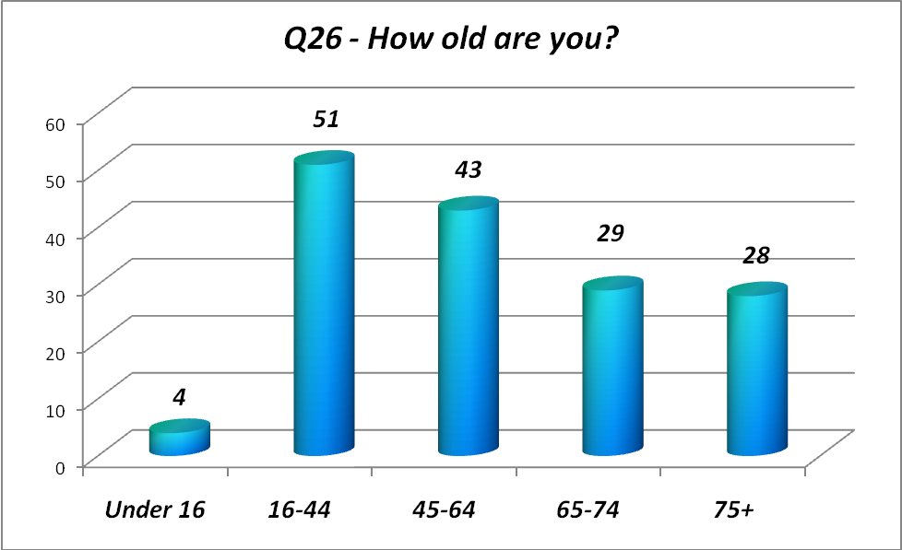
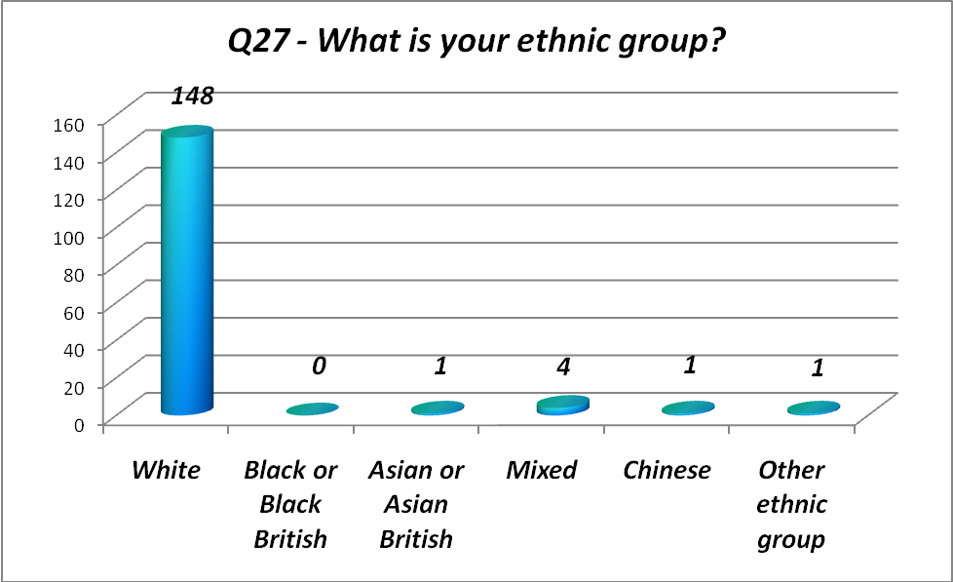
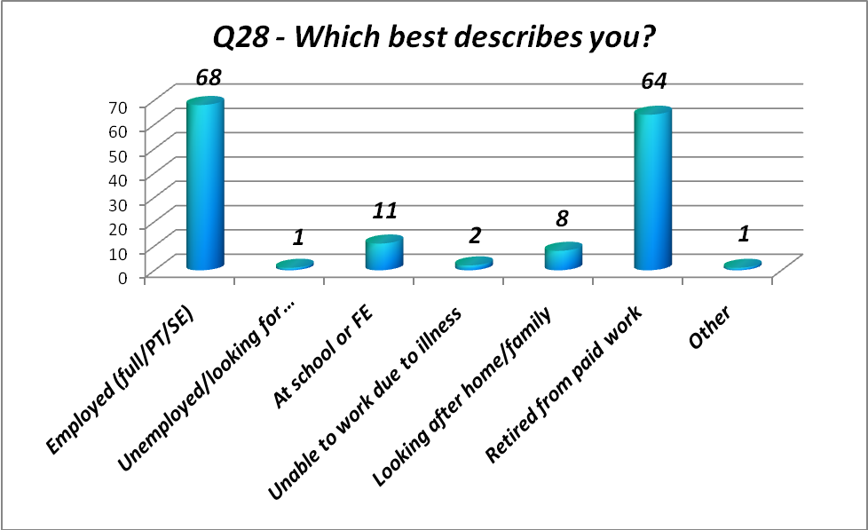

DISCUSSION ABOUT RESULTS
The full results and action plan were discussed and agreed with the PPG at the meeting 6/3/12 held at the surgery. Areas highlighted for focus were as follows –
- 57% of respondents fedback that it is ‘not very easy’ to get through to someone on the phone.
- 77% of respondents felt it is important to be able to book appointments ahead of time, compared to 60% who said they could get seen on the same day.
- 45% of respondents felt it was ‘fairly easy’ to book ahead, only 26% saying it was ‘very easy’.
- The highest rating given for being able to get an appointment is 60% feeling the service is ‘good’. We want to improve the ‘very good figure’ up from the current 19%.
It was felt that the strong feedback around the ability to ring, & get a suitable appointment was as a result of 3 factors:
- How appointments are made available (how soon can I get an appointment)
- How easy is the telephone system itself (there are no options – if you don’t speak to someone straight away a patient is put on hold)
- The restriction of only being able to ring the surgery or visit face to face to book an appointment.

ACTION PLAN
Action | Task | Timeline
Appointment availability | Review how soon appointments are available, so patients have a choice of same day, next few days as well as in advance for routine follow ups | New system to be in place for 1st May as a result of meetings held with the PM & GP’s 17/3 & 2/4.
Better use of telephone system | PM to consider what menu ‘options’ to be introduced. The numbers of options are to be kept to a useful minimum, as well being informative.  (this was agreed by the PPG at the meeting 6/3/12) | PM to meet with 1 other member of staff to set up the new options, as a result of input from the PPG at 6/3/12 meeting.  Effective by May 2012
Make some appointments available on the Internet | Agree portion of available appointments that will be made available over the internet, & set up the process to allow patients to sign up for the service. | In place for June 2012
Information available to patients (TV & Website) | To support health messages & messages about the surgery, 2 silent screens will be installed. This, along with development of the website will give patients access to more information by through other media, making information more accessible to all. | Television screens installed by 30th April.  Website development ongoing (with ability to use to book appointments online by June 2012

ACCESS

OPENING HOURS – Building Physically Open
Monday to Friday 0800-1830
Saturday open 0830 - 1130

EXTENDED HOURS
Open daily with last appointment available at 6.30pm. 1-2 nurses offering bookable appointments
Saturday open 0830 – 1130 – 1 GP offering bookable appointments

ACCESS TO SERVICES
Dorridge Surgery, 3 Avenue Road, Dorridge, Solihull, B93 8LH
Main Telephone Number 01564 776262 for all enquiries including booking appointments in advance and Same Day
Appointments can be booked in person or via the telephone.
When the surgery is closed outside of our on call hours 0800 – 1830 Monday to Sunday the telephone line, website and surgery front door provide the telephone number for the out of hours GP service called Badger. This telephone number is 0300 555 0303

PUBLICATION OF THE REPORT
The patient survey is available on www.dorridgesurgery.co.uk.
This action plan will be published on the same practice website, & will be available as hard copy in the surgery. A copy will be sent to Solihull Primary Care Trust.
This will all be in place by March 31st 2012.

